**The Happy Christmas Tree Office Scripts Video . A Demo App**

See the code at Greetings.ts.

See the video on my YouTube Channel at : https://youtu.be/HBiGEkzmkgo

The app demonstrates how animation is implemented in Excel Online. The code was built almost, completely, using the macro recorder. The entire script and its associated demo video was created in one day.

With the Macro recorder building solutions is, now, extremely rapid.

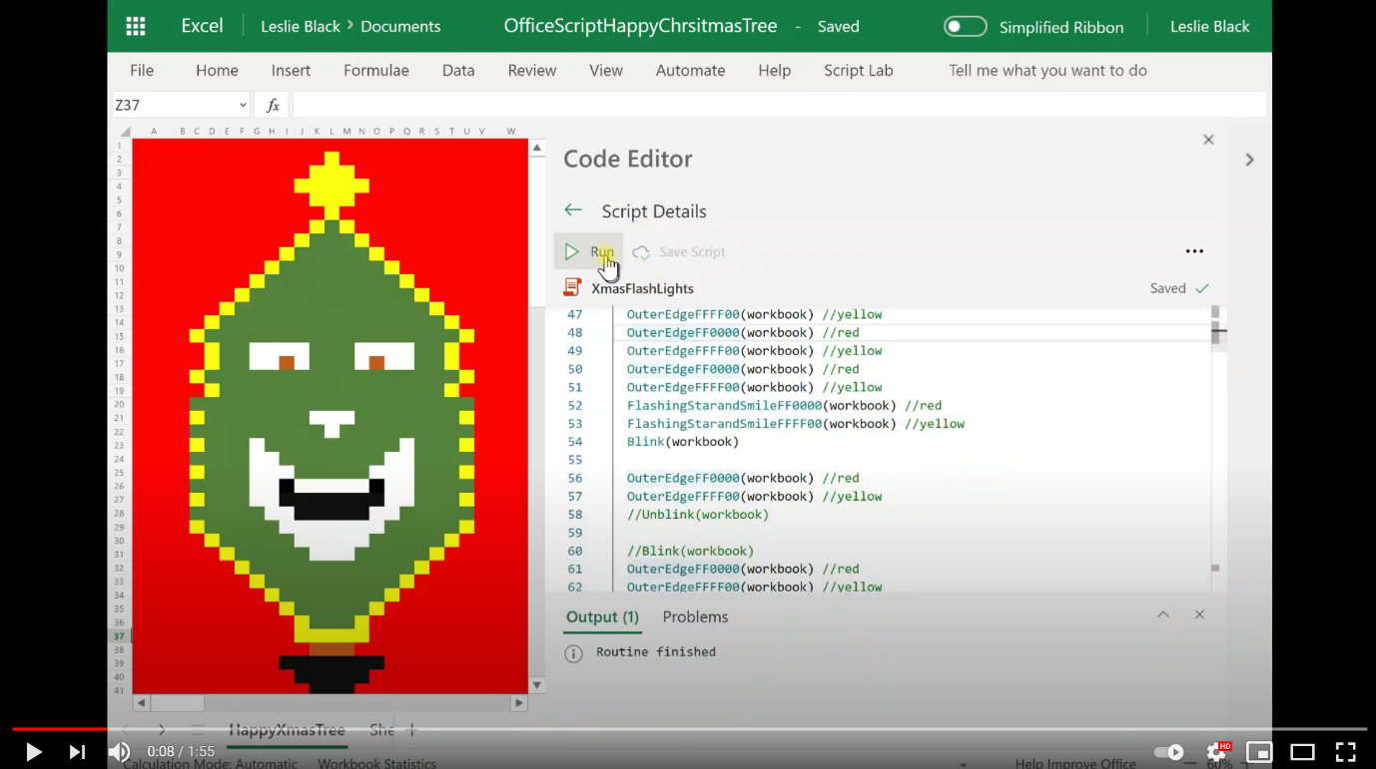

https://youtu.be/HBiGEkzmkgo